Nama : Aditia Surya Putra

Kelas : Flutter D

Soal 1

Source Code

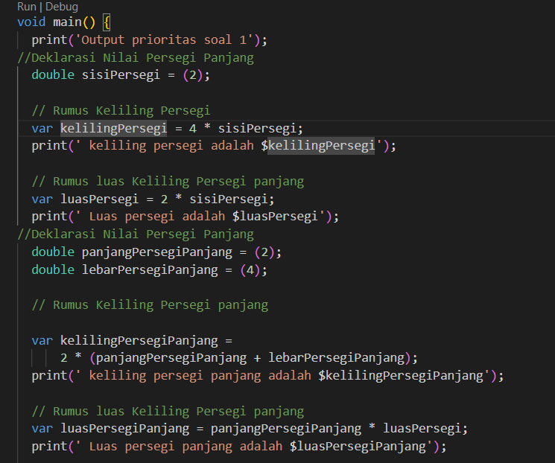

Output

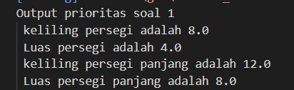

Soal 2

Source code

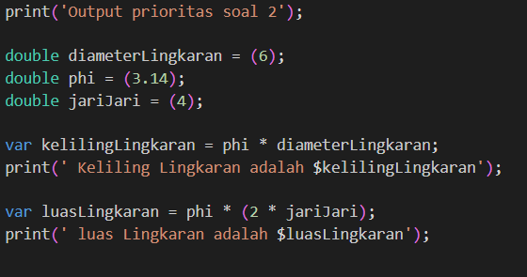

Output

